Privacy & Data Retention Policy
Enhancing Security in Messaging Applications
Spinnaker Analytics
29 June 2026

Table of Contents
- Introduction
- Privacy by Design Principles
- Data Classification
- Data Collection & Processing
- Data Retention Policy
- Secure Data Storage & Disposal
- User Privacy Rights
- Privacy Compliance & Security Controls
- Privacy Validation & Auditing
- Conclusion

1. Introduction

1.1 Purpose
- This document defines the privacy and data retention controls implemented within the messaging application.
- The objective is to protect user privacy by minimizing data collection, restricting retention periods, and ensuring secure handling and disposal of information throughout its lifecycle.

1.2 Objectives
- Apply Privacy-by-Design principles
- Minimize personal data collection
- Define retention schedules
- Protect stored metadata
- Support secure deletion
- Ensure regulatory compliance
- Protect user privacy throughout the data lifecycle

2. Privacy by Design Principles
The messaging application incorporates privacy into every stage of the system lifecycle.

2.1 Privacy by Design
Figure 27 – Privacy-by-Design Framework
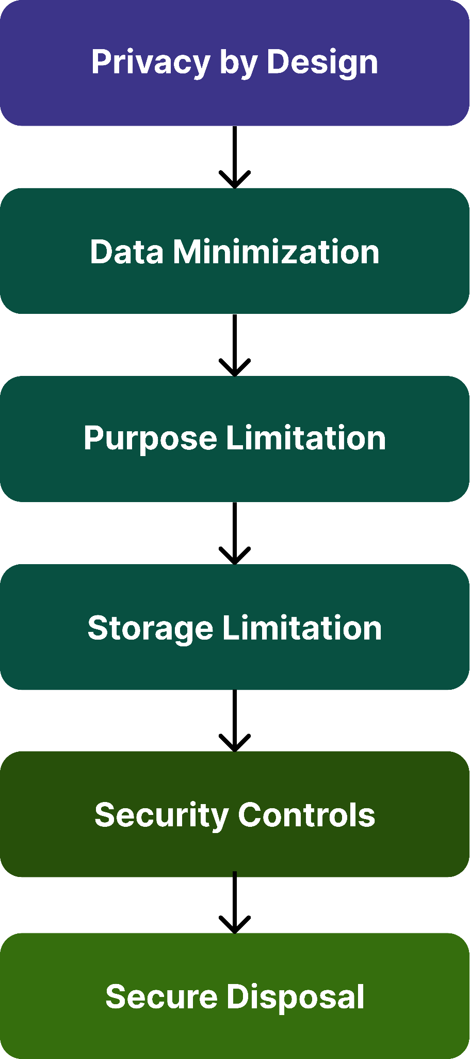

2.2 Core Principles
Principle | Implementation
Data Minimization | Only essential metadata collected
End-to-End Encryption | Message contents inaccessible to server
Purpose Limitation | Data used only for messaging functions
Storage Limitation | Automatic retention schedules
Integrity & Confidentiality | Encryption in transit and at rest
Accountability | Auditing and logging

3. Data Classification

3.1 Information Categories

Data Type | Classification | Protection
Message Content | Confidential | End-to-End Encryption
Voice Calls | Confidential | SRTP
Files | Confidential | AES-256-GCM
User Profile | Internal | Encrypted Database
Authentication Data | Restricted | Argon2id + MFA
System Logs | Internal | Access Controlled

Figure 28 – Data Classification Model
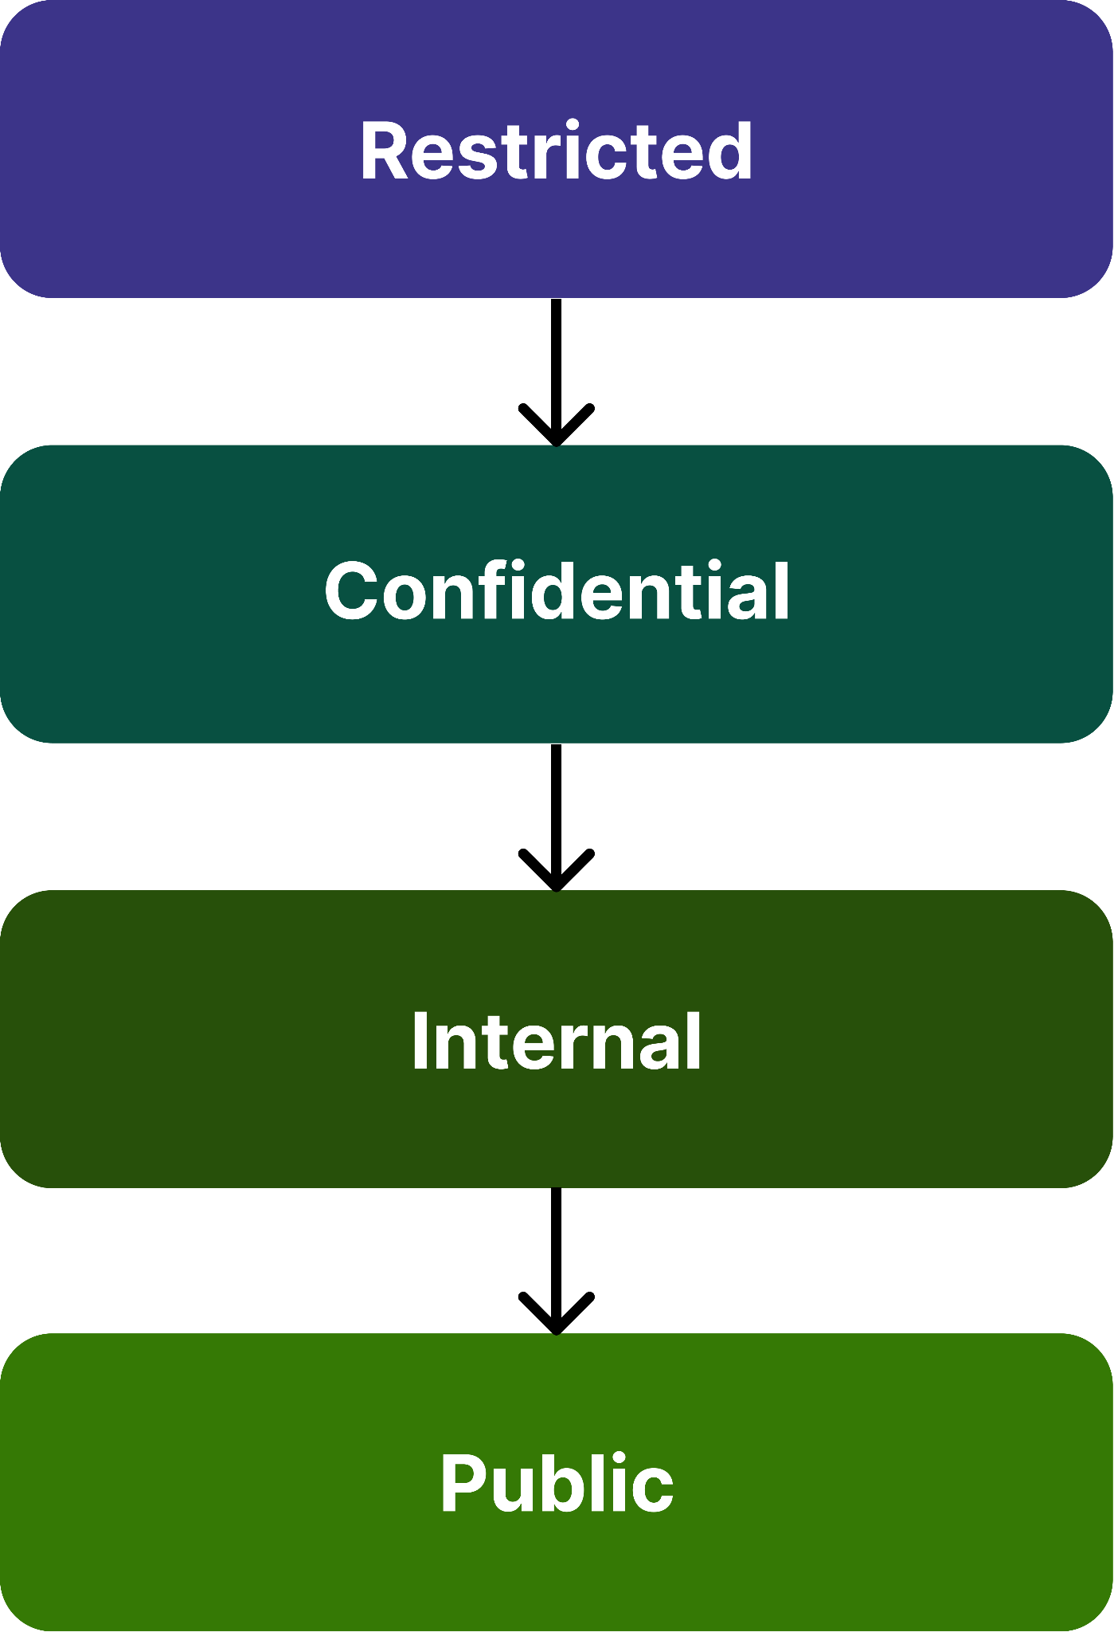

4. Data Collection & Processing

4.1 Data collected
Information | Purpose
Username | Account identification
Phone Number | User registration
Public Keys | End-to-end encryption
Device Identifier | Session management
Push Notification Token | Message notifications

4.2 Data Not Collected
- Message contents
- Voice recordings
- File contents
- Encryption keys
- Passwords in plaintext

5. Data Retention Policy

5.1 Retention Schedule

Data Type | Retention Period
Account Information | Until account deletion
Metadata | 30 Days
Authentication Logs | 90 Days
Security Logs | 180 Days
Incident Reports | 1 Year
Encrypted Backups | 30 Days

5.2 Data Lifecycle
Figure 29 – Data Lifecycle
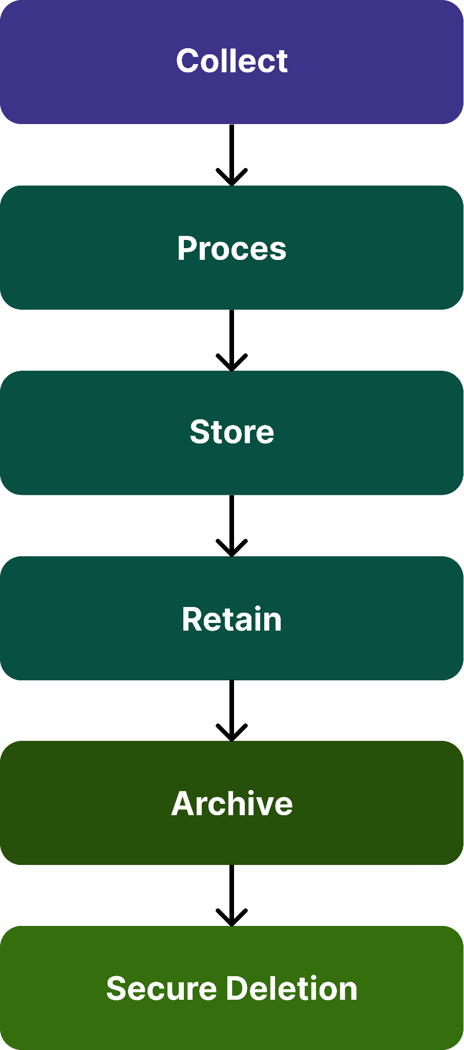

6. Secure Data Storage & Disposal

6.1 Storage Controls
- AES-256 encrypted databases
- SQLCipher for local storage
- Secure backups
- Role-based access control
- Key management through Secure Enclave / Android Keystore

6.2 Secure Deletion
Data Type | Deletion Method
Messages | Cryptographic Erasure
Files | Secure Overwrite
Metadata | Database Purge
Backups | Automated Expiry

7. User Privacy Rights
- Users may:
  - View stored account information
  - Request correction of personal information
  - Export account data
  - Delete their account
  - Withdraw consent where applicable
- Figure 30 – User Privacy Request Workflow
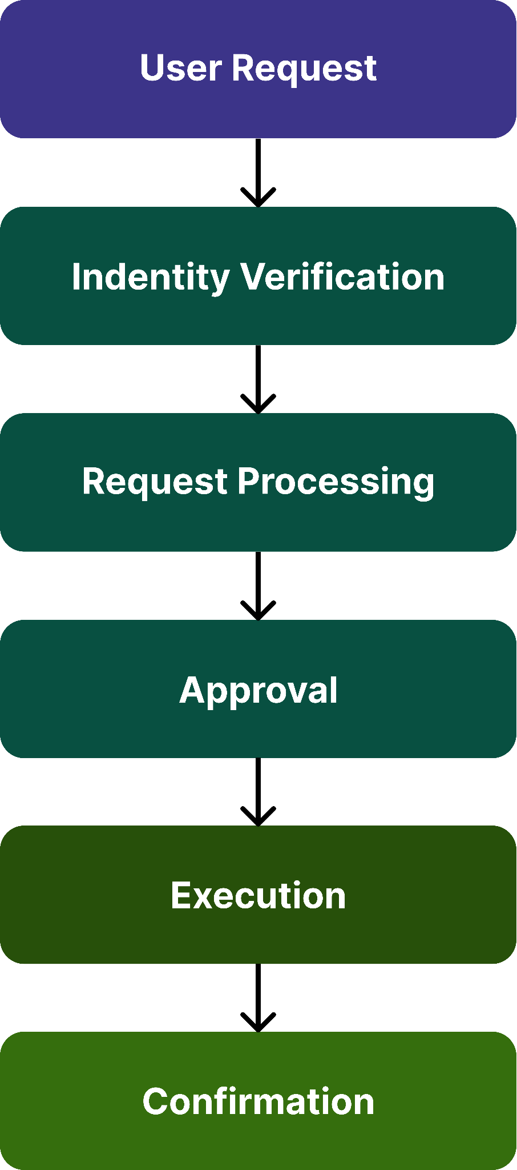

8. Privacy Compliance & Security Controls

8.1 Security Controls
Control | Purpose
TLS 1.3 | Secure transmission
AES-256-GCM | Data confidentiality
Signal Protocol | End-to-end encryption
RBAC | Access restriction
MFA | Administrative protection
Audit Logging | Accountability

8.2 Standards Alignment
Standard | Purpose
GDPR | Data protection principles
ISO/IEC 27001 | Information Security Management
NIST Privacy Framework | Privacy risk management
OWASP MASVS | Mobile application security

9. Privacy Validation & Auditing

9.1 Validation Tools
Tool | Purpose
MobSF | Mobile privacy assessment
Wireshark | Verify encrypted traffic
Wazuh | Log monitoring
OpenSSL | Certificate verification

9.2 Test Cases

Test ID | Scenario | Expected Result
PRIV-01 | Message inspection | No plaintext visible
PRIV-02 | Metadata review | Minimal metadata retained
PRIV-03 | Account deletion | Data removed
PRIV-04 | Backup expiry | Automatic deletion
PRIV-05 | Traffic capture | Encrypted communications

10. Conclusion
- This Privacy & Data Retention Policy establishes a privacy-first framework for the messaging application.
- By applying Privacy-by-Design principles, limiting data collection, enforcing defined retention schedules, protecting stored information with strong cryptography, and supporting secure deletion, the application safeguards user information while maintaining compliance with recognized security and privacy practices.

